Name: Rahul Surana

Assignment Date: 09-OCT-2022

**Assignment-1**

Connect and disconnect with login Access

* What happens when you login a non-existent users or username?
  + Provide Screenshot and What you understand, explain in short brief?

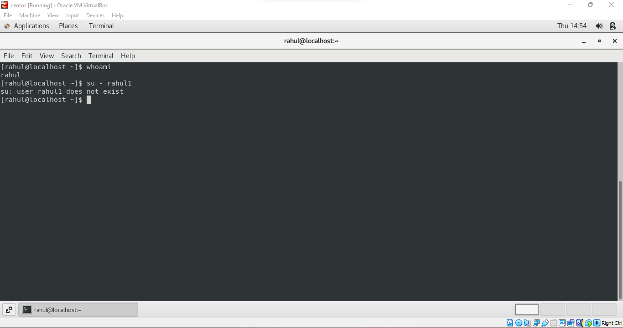

As we can see in the above screenshot that the terminal responses with the user does not exist when we give a non-existent username.

**Assignment-2**

Password changing

* Login into your account and then change password?
  + Change your password into ***IneuR0n#42*** and hit the **Enter** key
    - Explain what happen and give screenshot?

When the password is changed to **IneuR0n#42**, the password is accepted and the terminal says that the all authentication tokens updated successfully.

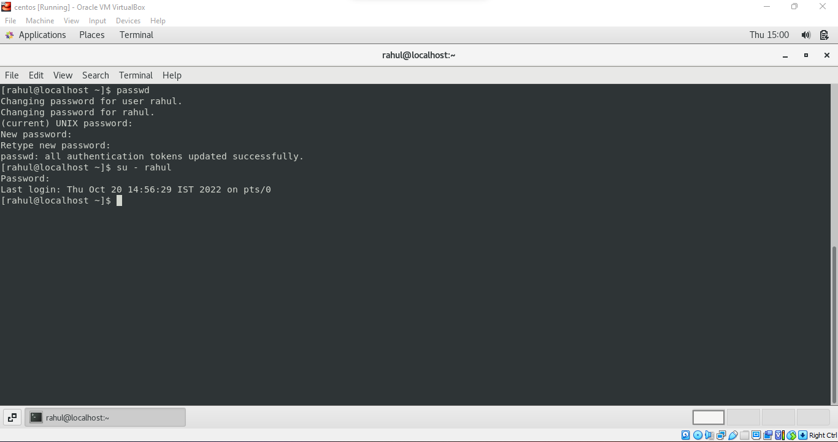

* + Try again to change password but use like password ***1234*** or ***abcd***
    - Explain what happen and give screenshot?

When the password is changed to **abcd,** the password was not accepted saying that it needs to be longer or of at least of 8 characters.

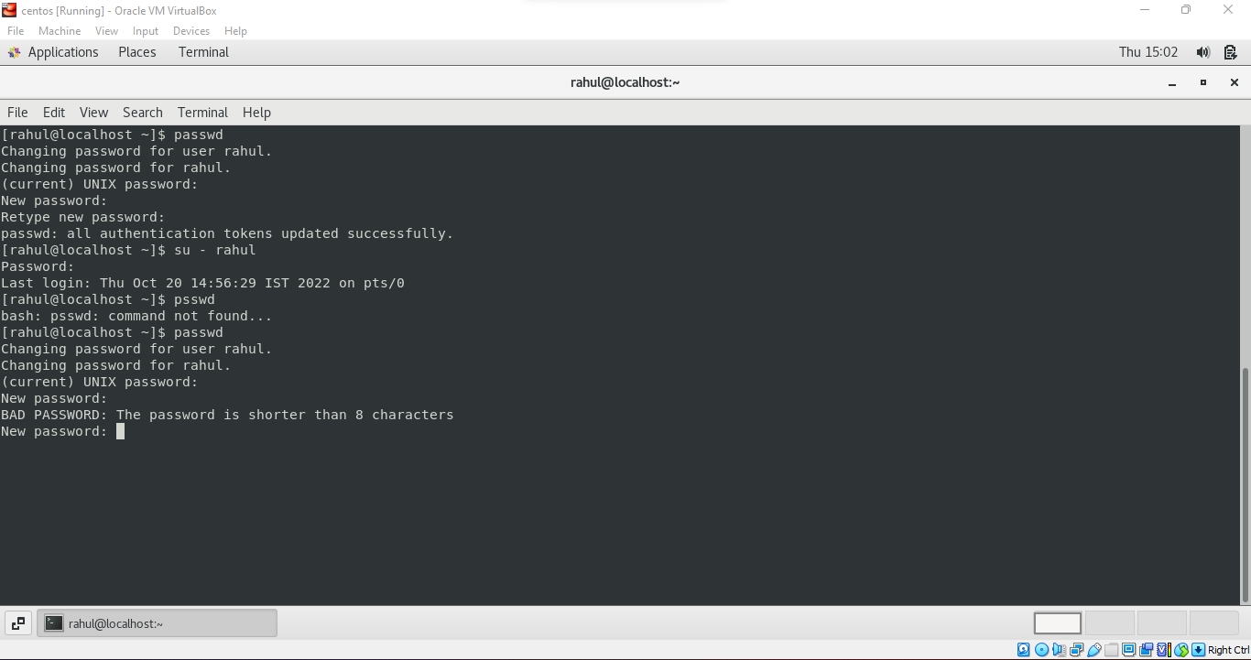

* + Try again to change password but now don’t use any password just hit **Enter** key
    - Explain what happen and give screenshot?

When tried leaving the password blank, it says that no password is supplied as seen in the below screenshot.

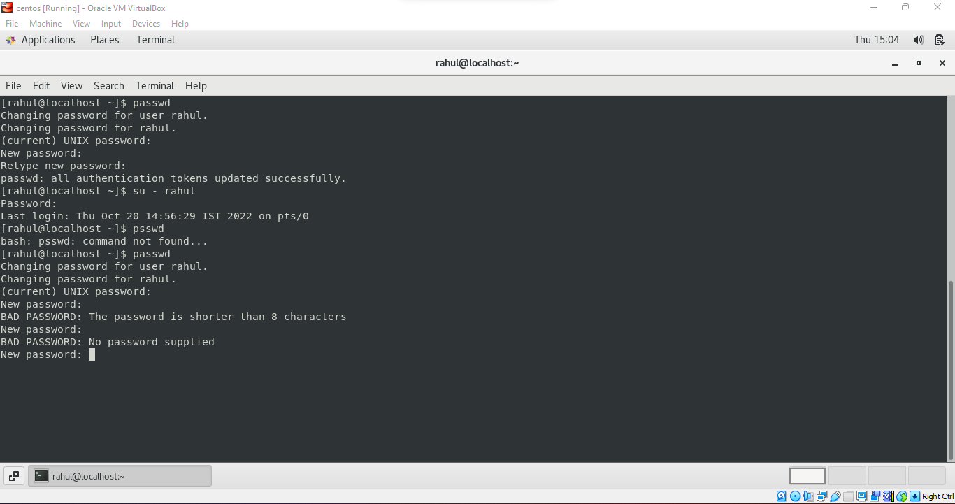

**Assignment-3**

Working with Directories

* Enter the command **cd /** and then **ls** and then hit **Enter** key
  + Take screenshot and explain what output we got?

The command **cd /** takes us to the root directory and the **ls** command is showing us all the available folders in that directory.

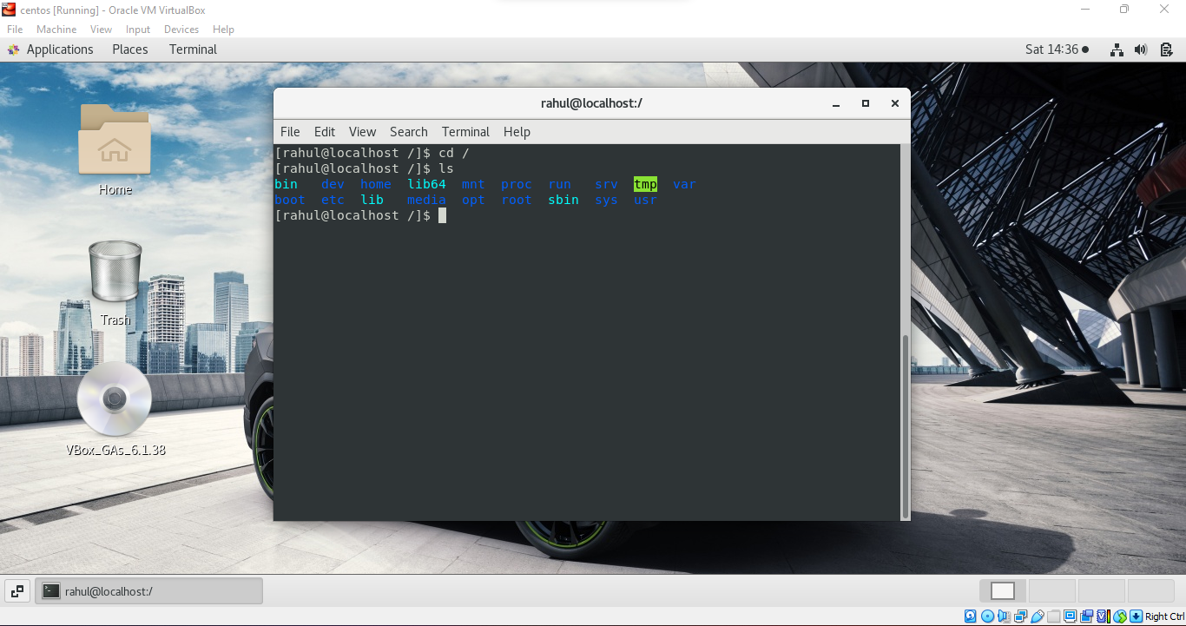

* Enter the command now **cd /home** and then hit **Enter** key
  + Do **ls,** provide screenshot and explain what is **/home** directory used for?

The command **cd /home** changes the directory to home and the command **ls** lists the folders or directories present in home. The home directory is used to list or access available files or folders of the user.

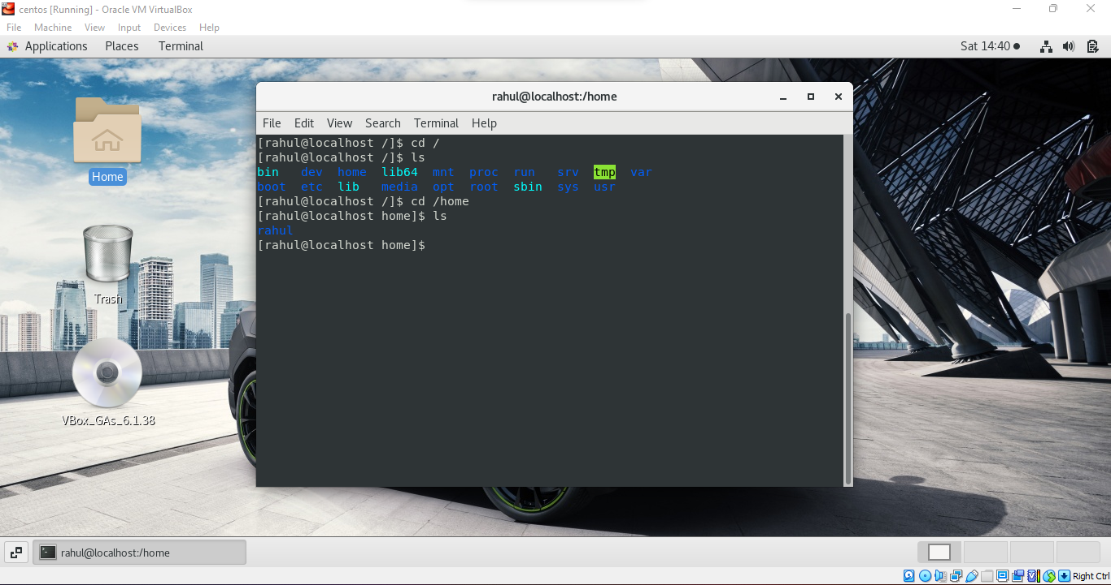

* Enter **cd ..** and hit **Enter** key [ *Note: here we have space after cd then use double dot*]
  + Check what happen and give screenshot?

The command **cd ..** takes us to previous or parent directory of home.

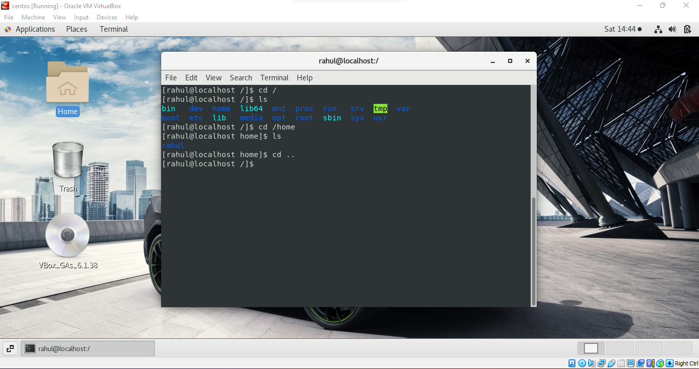

* Now enter **cd /var/www/html** and then type **cd** and hit **Enter** key
  + Explain what happen and give screenshot?

There is a directory named var but there is no file or directory named www.

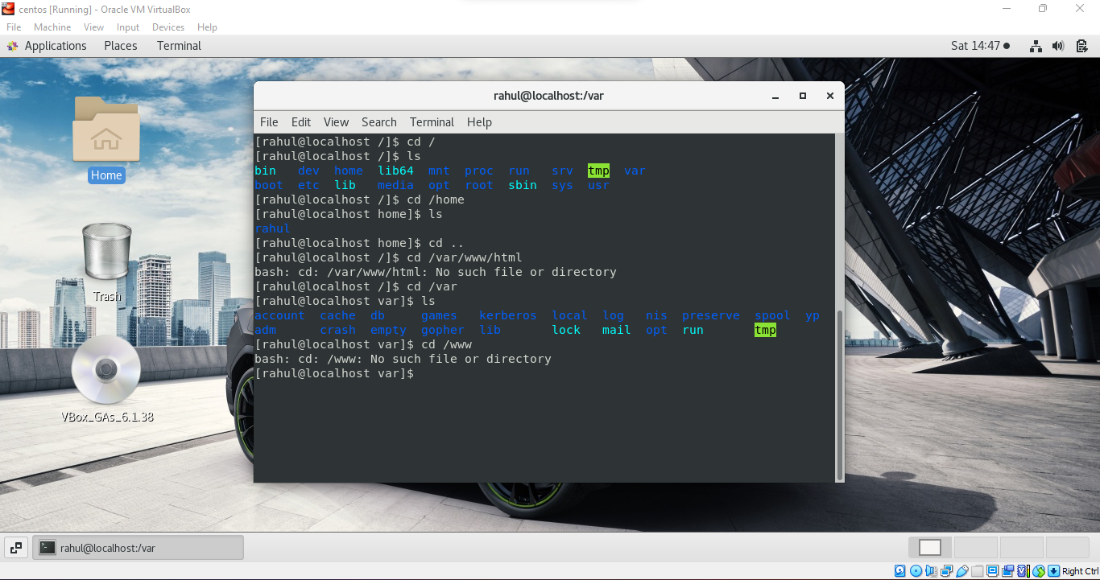

* Now type **cd /root** and then hit **Enter** key
  + Do **ls,** check any output we have on screen if yes then take screenshot?

The command **cd /root** when entered, we are shown that the permission is denied.

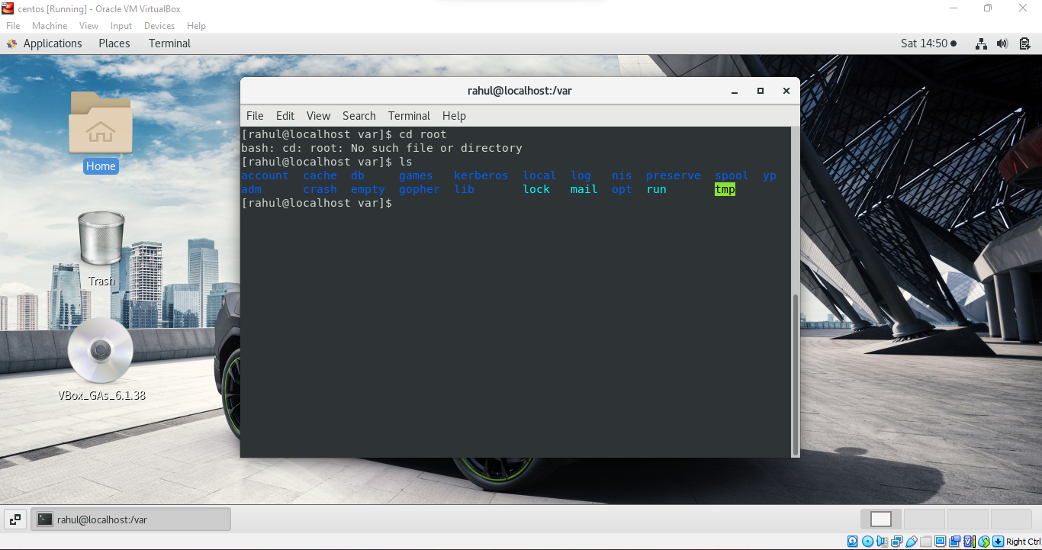

**Assignment-4**

Working with File Listing

* Go to **cd /etc** and type **ls**
  + Take screenshot and explain what files you have seeing?
  + Take screenshot and explain what different output you found compare to previous command you used?

The command **cd /etc** moves us to etc directory and the command **ls** lists out all the files and directories present in etc alphabetically.

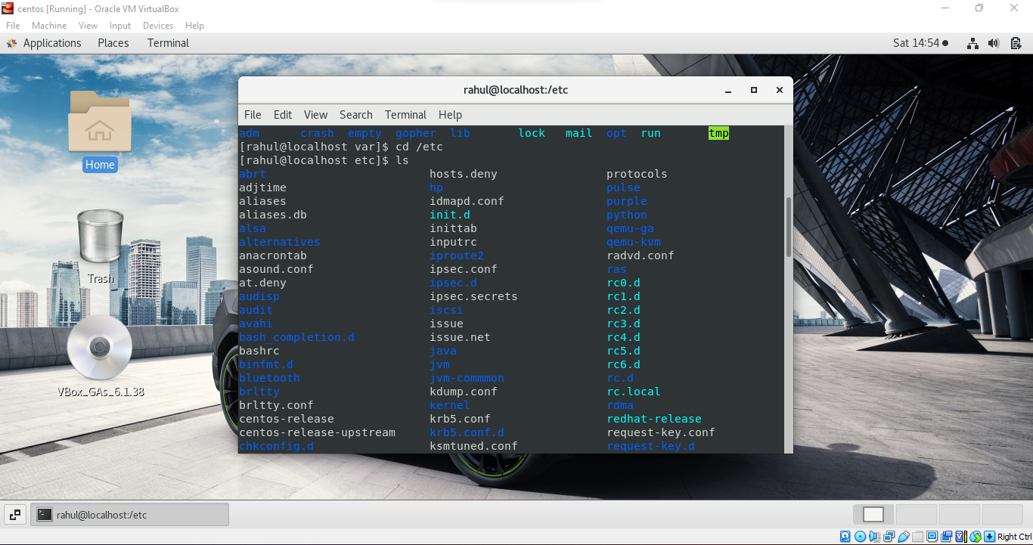

* Then type **ls -al** and hit **Enter** key
  + Take screenshot and explain what new file or directory you found?

The command **ls -al** lists out all the files with their detailed information like the file type, permissions, root, creation time etc.

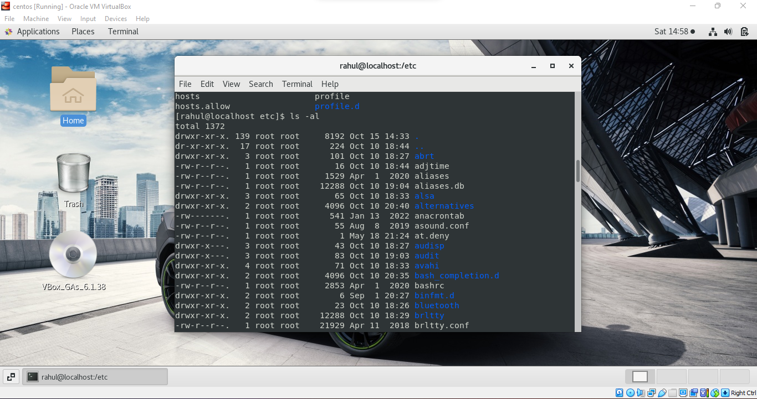

* Then use **ls -i** and hit **Enter** key
  + Now see what different output its shows and take screenshot?

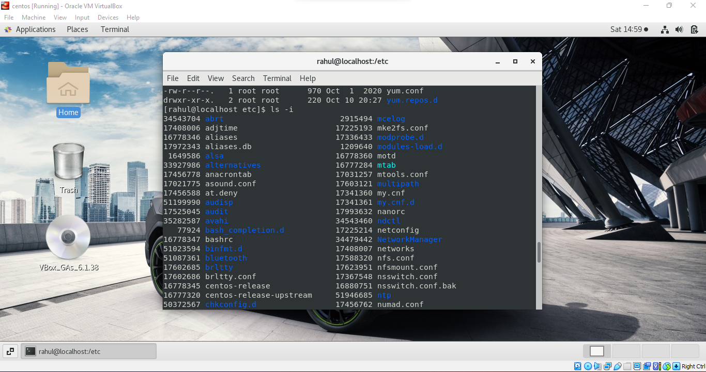

* Then use **ls –help** and see other options about **ls** command
  + Explore it and try with other attribute we can use with **ls** command

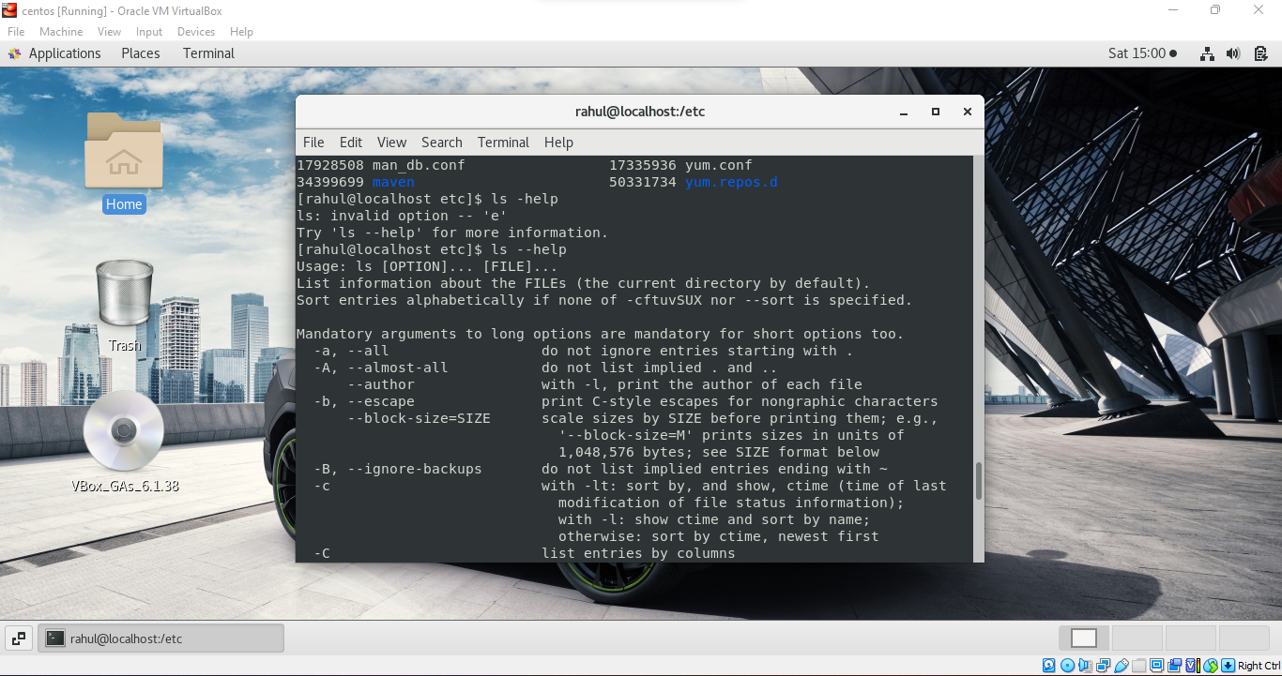

**Assignment-5**

Know where you are and where you working

*Here we use* ***pwd, cd and ls*** *as combine task to understand where you working on terminal and how you can switch from one directory to another one.*

* Open terminal after restart the linux
  + Check which location you working, type **pwd** and take screenshot

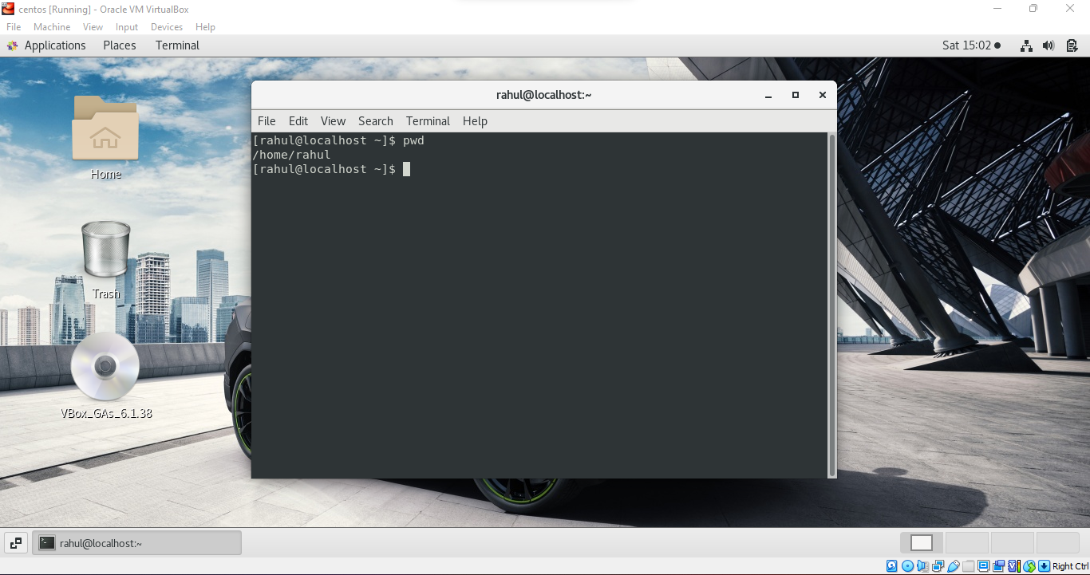

* Now use **cd /var** and hit **Enter** key
  + Do **ls,** and see what output comes, give screenshot?

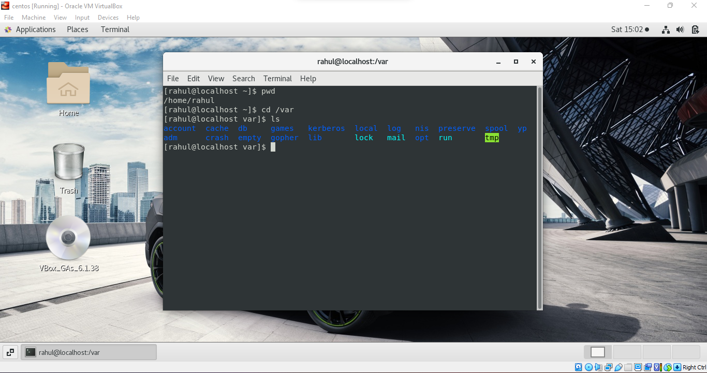

* Do explore other help options of each command to learn more other things we can do with these commands